**Lab 01 - Modulation**

# Part I: Scavenger Hunt

Find the hidden signal that is being broadcast within the range

## Instructions

1. Connect to one of the remote radios listed below using SDR#.
2. Scan through the signals, the signal uses a narrow bandwidth
3. Listen to the audio through your speakers, you’ll find a few different transmissions. If at first you think you’re getting trolled by the Russians, you’re close, but the trolling isn’t the secret message itself.
4. Take a screenshot of discovering the signal. What is the signal saying (audio)?

## Findings and Analysis

The secret message is "Mary had a little lamb, its fleece was white as snow."

Figure 1: Secret Message Signal

# Part II: Triangulation

estimate the rough location of a mobile device given three base stations and

key parameters such as received power, distance, and antenna gains

## Instructions

We know the basics for the relationship between received power, distance, and antenna gains. Given this information, we should be able to determine a mobile device’s rough location. In our scenario, we’re assuming we have free space propagation and that in our mystical world, all antennas’ gains are 1. Given the information below, determine the approximate location of the mobile device. Make sure to show/explain/demonstrate how you determined the location and show what you’ve found on some sort of a map. How you choose to render the map is up to you.

## Findings and Analysis

### **Setup**

Establish groundwork for subsequent distance calculations by introducing Friis Formula, transforming it into a distance formula, and calculating wavelengths

#### Friis Formula

|  |  |  |
| --- | --- | --- |
|  | | |
|  | Received Power  *strength of the signal as it arrives at the receiving antenna* |
|  | Gain of Receiving Antenna  *how effectively receiving antenna captures incoming signal* |
|  | Gain of Transmitting Antenna  *how effectively transmitting antenna sends signal in a particular direction* |
|  | Transmitted Power  *initial signal power transmitted from transmitting antenna* |
|  | Distance Between Transmitting and Receiving Antennas  *Note: units for wavelength and distance must be the same* |
|  | Wavelength of Signal  *Note: units for wavelength and distance must be the same* |

#### Calculate Distance Formula

Transform the Friis formula to a distance formula to directly calculate the approximate distance () between a mobile device and each base station.

|  |  |
| --- | --- |
|  | *formula* |
|  | *fraction rule* |
|  | *multiply both sides by* |
|  | *divide both sides by* |
|  | *take square root of both sides* |
|  | *fraction rule*  *if ,*  *then* |

#### Calculate Wavelength

given that all frequencies are 450 kHz, the wavelength () can be determined before proceeding

|  |  |
| --- | --- |
|  | *formula* |
| kHzHzHz | *convert frequency to Hz* |
| m/s | *notate speed of light* |
|  | *input values* |

### **Calculate Distances**

perform calculations to determine distance for each specific base station using given formulas and information

#### Base Station 1

##### Information

|  |  |
| --- | --- |
| *Location* | , |
| *Power Transmitted* | w |
| *Power Received* | w |
| *Transmitter Gain* |  |
| *Receiver Gain* |  |
| *Frequency* | kHz ( Hz) |

##### Calculate Distance

|  |  |
| --- | --- |
|  | *distance formula* |
|  | *input known value* |
|  | *solve for* |
|  | *multiplication* |
|  | *division* |
|  | *solve for square root* |
| m | *multiplication* |

##### Map View

Figure 2: Base 2 | , , m

[View on Map](https://www.freemaptools.com/radius-around-point.htm?lat=44.012320&lng=-97.109509&r=2847.860)

#### Base Station 2:

##### Information

|  |  |
| --- | --- |
| *Location* | , |
| *Power Transmitted* | w |
| *Power Received* | w |
| *Transmitter Gain* |  |
| *Receiver Gain* |  |
| *Frequency* | kHz ( Hz) |

##### Calculate Distance

|  |  |
| --- | --- |
|  | *distance formula* |
|  | *input known value* |
|  | *solve for* |
|  | *multiplication* |
|  | *division* |
|  | *solve for square root* |
| m | *multiplication* |

##### Map View

Figure 3: Base 3 | , , m

[View on Map](https://www.freemaptools.com/radius-around-point.htm?lat=44.013371&lng=-97.289582&r=11877.106)

#### Base Station 3:

##### Information

|  |  |
| --- | --- |
| *Location* | , |
| *Power Transmitted* | w |
| *Power Received* | w |
| *Transmitter Gain* |  |
| *Receiver Gain* |  |
| *Frequency* | kHz ( Hz) |

##### Calculate Distance

|  |  |
| --- | --- |
|  | *distance formula* |
|  | *input known value* |
|  | *solve for* |
|  | *multiplication* |
|  | *division* |
|  | *solve for square root* |
| m | *multiplication* |

##### Map View

Figure 4: Base 3 | , , m

[View on Map](https://www.freemaptools.com/radius-around-point.htm?lat=44.119244&lng=-97.215958&r=12276.623)

### **Triangulate Mobile Device**

use calculated distances to triangulate location of mobile device

In the process of locating the mobile device, circles were overlayed on a map to represent the calculated distances from each individual base station. The convergence point (where these circles intersect) reveals the approximate location of the mobile device. The screenshots below illustrate this process.

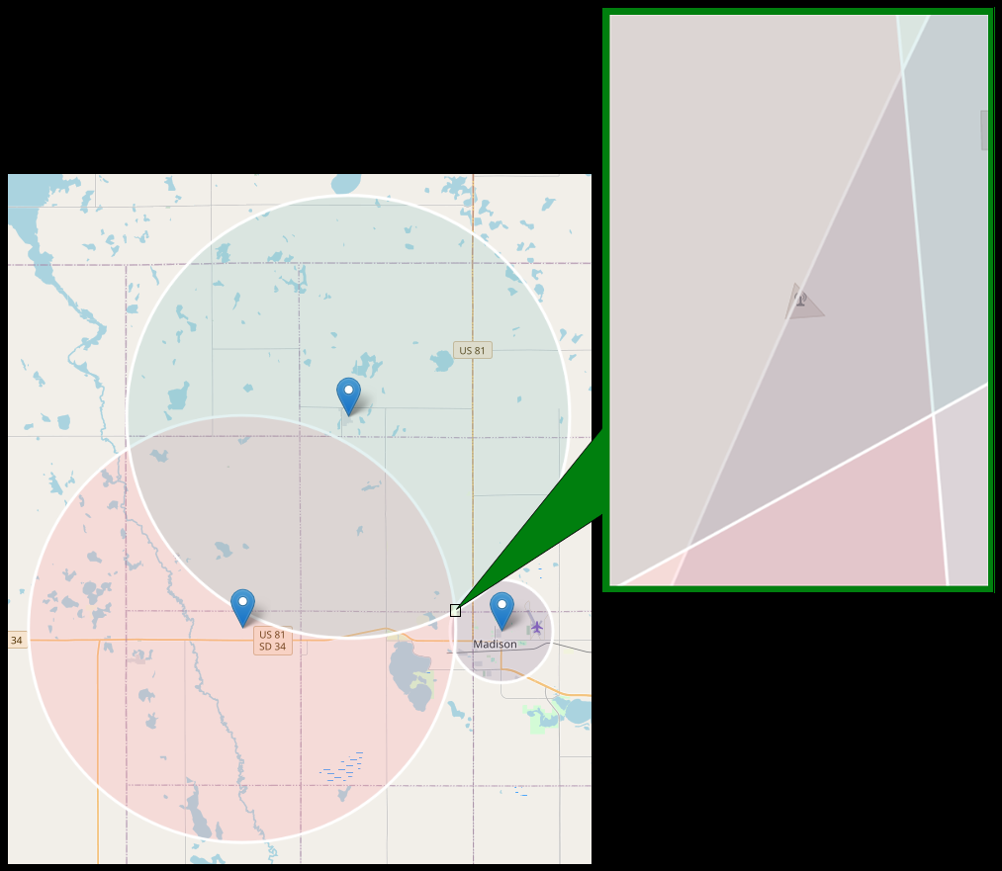

Figure 5: OpenStreetMap view of Convergence Point

The OpenStreetMap (OSM) view shown in Figure 5 displays overlapping circles, with the convergence point outlined. When zooming in on this focal point, a cell tower icon can be seen, which confirms accurate triangulation.

Figure 6: Cell Tower Icon

[View on Map](https://www.freemaptools.com/radius-around-point.htm?lat=44.022843&lng=-97.141968&r=5.492833966313597)

By drawing a circle around this icon, as shown in Figure 6, the exact location is determined to be , , or N W

Figure 7: Satellite View

[View on Map](https://maps.app.goo.gl/rT51wKDCPCxAX25d9)

Figure 8: Street View

[View on Map](https://maps.app.goo.gl/b7vE62V3bKyrUZUx5)

Lastly, by examining Google Satellite View (Figure 7) and Google Street View (Figure 8), the triangulation location is further validated. The Satellite View provides an aerial perspective of the tower, while Street View provides a view from ground level.